**Instagram User Analytics**

**Project Description**

This project focuses on analyzing Instagram user data using SQL to derive valuable insights for marketing, product, and investor-related decisions. The analysis aids in identifying trends, user behavior, and potential opportunities to optimize user engagement and platform performance.

The tasks in this project simulate a data analyst's role in helping a product team make informed decisions based on user interactions and engagement. Using MySQL Workbench as the primary tool, insights are extracted to answer specific questions posed by management, marketing, and investors.

**Approach**

The project is divided into two sections:

1. **Marketing Analysis:** Focused on user engagement and marketing strategy.
2. **Investor Metrics:** Focused on platform health and fake account detection.

Steps followed:

1. Created a database and tables using the provided schema.
2. Inserted data into the tables.
3. Designed and executed SQL queries to answer specific questions.
4. Compiled results into a report with insights.

**Tech-Stack Used**

* **SQL Tool:** MySQL Workbench
* **Database Management System:** MySQL
* **Languages:** SQL (Structured Query Language)
* **Reason for Choosing:** MySQL Workbench is user-friendly, widely used, and supports efficient query execution for relational databases.

**SQL Tasks and Queries**

1. **Marketing Analysis**

**1. Loyal User Reward**

* **Objective:** Identify the five oldest users on Instagram.
* **Code :**

Select

*

From

Users

Ordered by create_at

Limit 5;

**Result:**

|  |  |  |
| --- | --- | --- |
| User ID | Username | Created At |
| 1 | Kenton_Kirlin | 2017-02-16 |
| 2 | Andre_Purdy85 | 2017-04-02 |
| 3 | Harley_Lind18 | 2017-02-21 |
| 4 | Arely_Bogan63 | 2016-08-13 |
| 5 | Aniya_Hackett | 2016-12-07 |

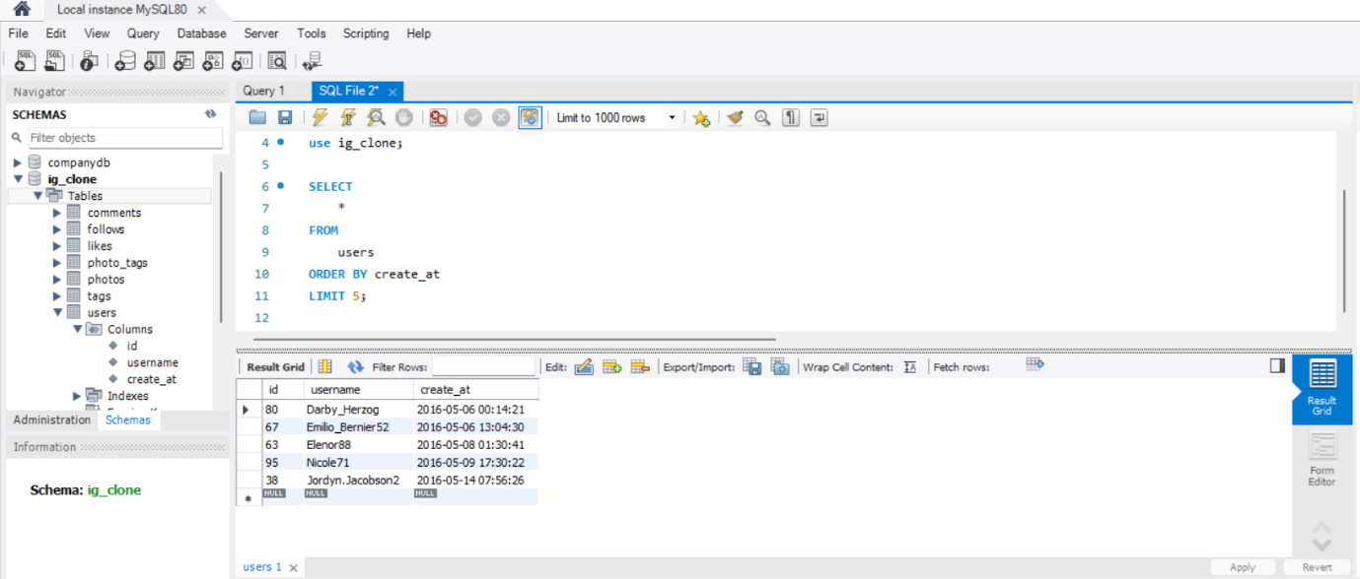

**Insights:** The five oldest users on Instagram can be rewarded to enhance loyalty and motivate others to engage more with the platform.

**2. Inactive User Engagement**

* **Objective:** Identify users who have never posted a single photo.
* **code:**

Select

*

From

Users

Left join

Photos on users.id = photos.user_id

Where

Photos.users_id is null;

**Result:**

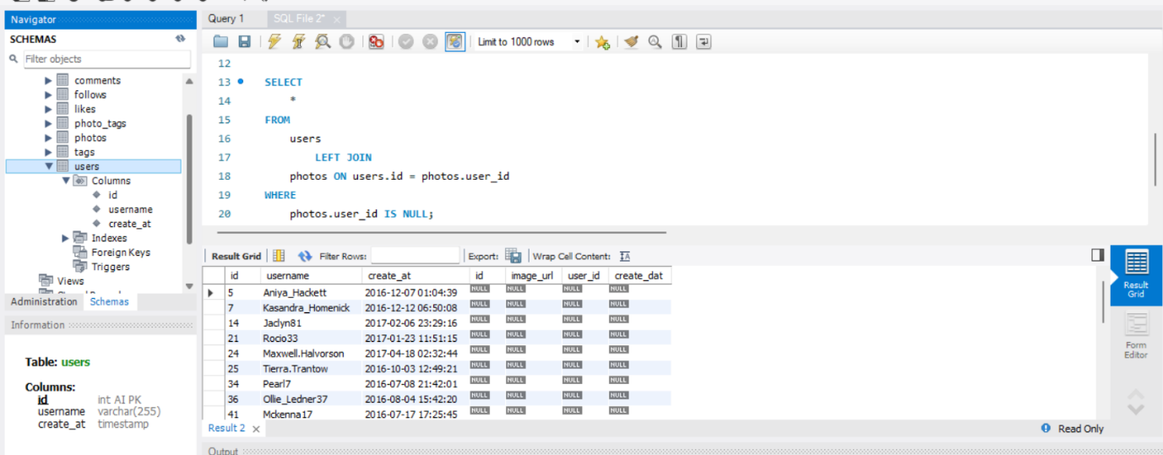

**Insights:** These users represent an untapped audience. A targeted email campaign encouraging them to post can improve engagement.

**3. Contest Winner Declaration**

* **Objective:** Determine the user with the most likes on a single photo.
* **code:**

SELECT

photos.id,

photos.image_url,

users.username,

COUNT(likes.user_id) AS total_likes

FROM

photos

JOIN

likes ON likes.photo_id = photos.id

JOIN

users on photos.user_id = users.id

GROUP BY photos.id

ORDER BY total_likes DESC

LIMIT 1;

**Result:** the person who has most like on single image is

Zack_kemmer93 and the number of likes are 48

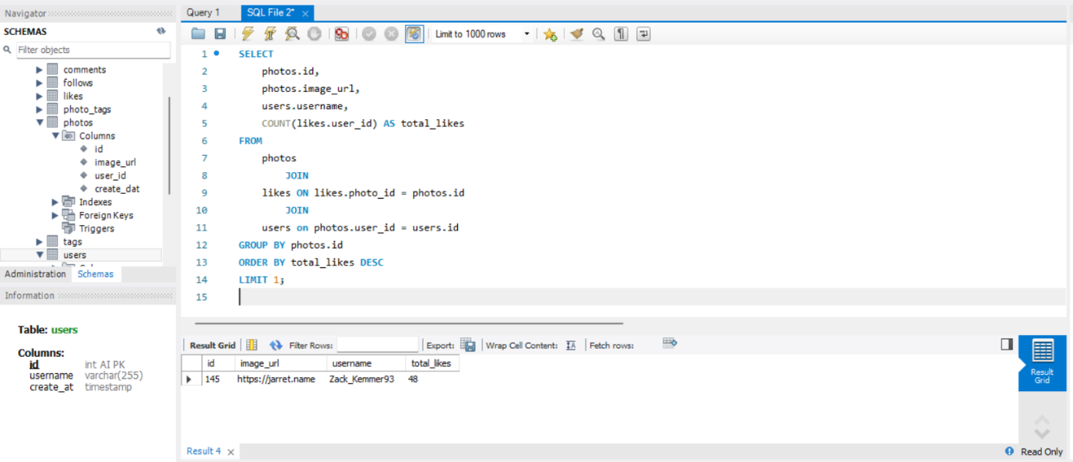

* **Insights:** Announcing the winner of the contest can improve user participation and drive future campaigns.

**4. Hashtag Research**

* **Objective:** Identify and suggest the top five most commonly used hashtags.
* **code:** SELECT

tags.tag_name, COUNT(*) AS total_tags

FROM

photo_tags

JOIN

tags ON photo_tags.tag_id = tags.id

GROUP BY tags.id

ORDER BY total_tags DESC

LIMIT 5;

**Result:** top five commonly used hashtages are

smile,beach,party,fun,concert

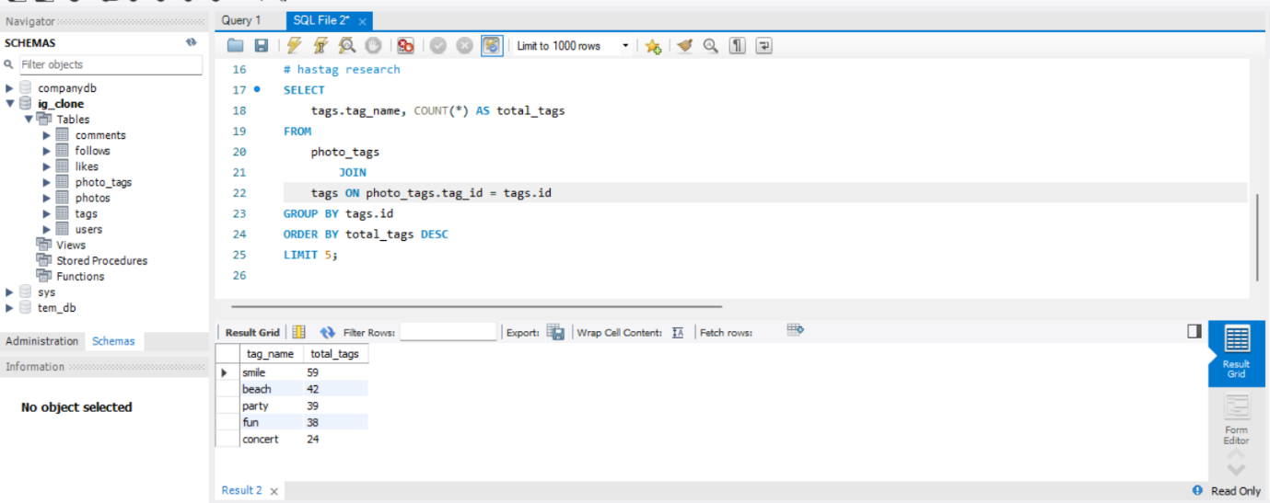

**Insights:** Partner brands can use these popular hashtags to maximize their reach and visibility.

**5. Ad Campaign Launch**

* **Objective:** Determine the day of the week when most users register on Instagram.
* **code:**

SELECT

DAYNAME(create_at) AS day, COUNT(*) AS total_reg

FROM

users

GROUP BY day

ORDER BY total_reg DESC

LIMIT 1;

**Result:** the most users registered on Instagram on Thursday

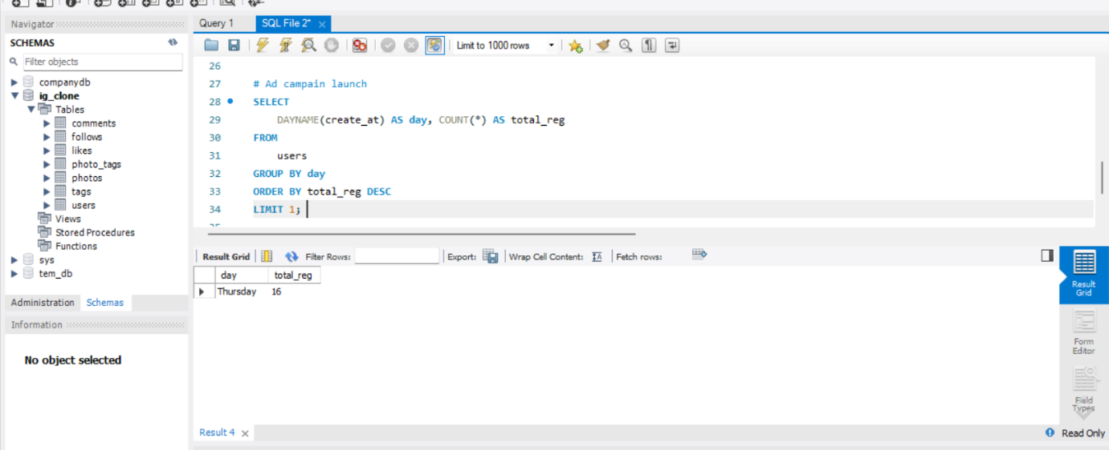

* **Insights:** Launching ads on the most popular day of user registration can optimize campaign success.

**B) Investor Metrics**

**1. User Engagement**

* **Objective:** Calculate the average number of posts per user and the total number of photos divided by the total number of users.
* **code:**

SELECT

(SELECT

COUNT(*)

FROM

photos) / (SELECT

COUNT(*)

FROM

users) AS avg;

**Result:** average number of posts per user are 2.5700

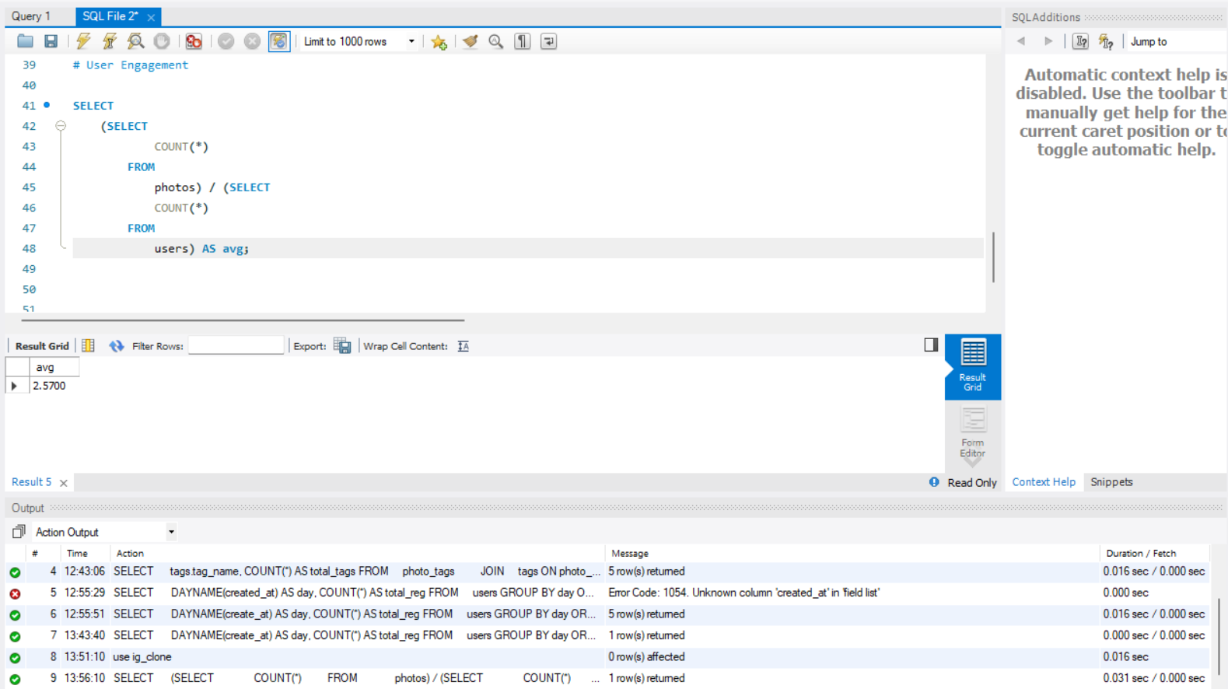

**Insights:** This analysis provides a baseline for user engagement and content generation trends.

**2. Bots & Fake Accounts**

* **Objective:** Identify users who have liked every single photo on the platform.
* **code:**

SELECT

users.username, COUNT(*) AS tot_num_likes

FROM

users

JOIN

likes ON users.id = likes.user_id

GROUP BY users.id

HAVING tot_num_likes = (SELECT

COUNT(*)

FROM

photos);

**Result:** Identify users who have liked every single photo on the platform are as followes

|  |  |  |
| --- | --- | --- |
| username | tot_num_likes | |
| Aniya_Hackett | 257 |  |
| Jaclyn81 | 257 |  |
| Rocio33 | 257 |  |
| Maxwell.Halvorson | 257 |  |
| Ollie_Ledner37 | 257 |  |
| Mckenna17 | 257 |  |
| Duane60 | 257 |  |
| Julien_Schmidt | 257 |  |
| Mike.Auer39 | 257 |  |
| Nia_Haag | 257 |  |
| Leslie67 | 257 |  |
| Janelle.Nikolaus81 | 257 |  |
| Bethany20 | 257 |  |

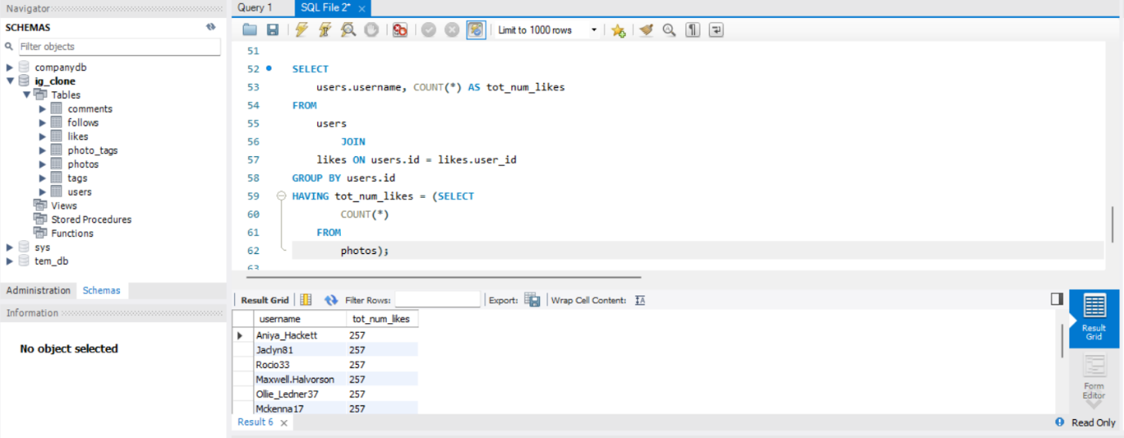

* **Insights:** Detecting potential bots or fake accounts helps maintain platform integrity and ensures a fair user experience.

**Insights:**

1. **Loyal User Reward:**
   1. By identifying the five oldest users, the platform can honor and acknowledge their contribution to the community. Rewards such as badges, special mentions, or exclusive content access can reinforce user loyalty and encourage newer users to strive for similar recognition.
2. **Inactive User Engagement:**
   1. Inactive users represent a large pool of untapped potential. Targeted campaigns (e.g., promotional emails, exclusive content for first posts) can help convert them into active contributors, increasing overall platform engagement.
3. **Contest Winner Declaration:**
   1. Announcing contest winners builds excitement and fosters a competitive spirit. Highlighting user achievements can also act as inspiration for other users to engage more actively with the platform.
4. **Hashtag Research:**
   1. Hashtags play a vital role in content discovery. Providing partners and brands with data-driven hashtag recommendations ensures their campaigns resonate with a broader audience, ultimately enhancing Instagram’s reputation as a marketing platform.
5. **Ad Campaign Launch:**
   1. Insights into user registration trends allow for precise targeting of ad campaigns. This ensures that marketing efforts are optimized for visibility and reach, maximizing return on investment.
6. **User Engagement Metrics:**
   1. Average posts per user and photos per user highlight the platform’s overall engagement levels. These benchmarks help in tracking growth and ensuring that user activity scales with new registrations.
7. **Bots and Fake Accounts:**
   1. Detecting and removing bots ensures fair competition and maintains the integrity of engagement metrics. This is crucial for investor confidence and user trust.